The Wildlife Society  san Francisco Bay Area Chapter  Workshop/Professional Development Scholarship Application | 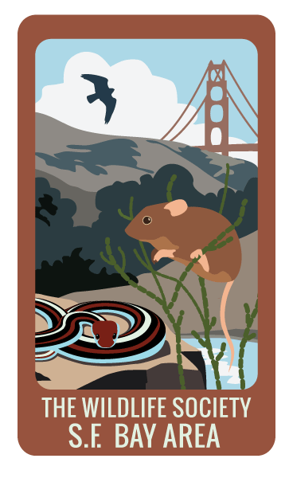
INSTRUCTIONS: To qualify for a TWS S.F. Bay Area chapter workshop/professional development scholarship,
please complete the following application in full.

Completed applications should be submitted to Ivan Parr (ivan.parr@aecom.com) on or before the advertised
submittal date: September 24, 2015. Incomplete or late submissions will not be considered.

All applicants will be notified of their submission status within a week of the submittal due date.

Name of Event
Event Name |  | Western Pond Turtle Workshop: Ecology and Conservation |  |  |  |  |  |  |  |  |  |  |  |  |  |  |  |  | Date |  | October 24, 2015
Event Fee |  |  |  | $40.00 |  |  |  | Scholarship Amount Requested (if less than Event Fee)
Are you receiving additional financial support to attend this event outside of the chapter (i.e. from an employer or TWS Western Section/National)? |  |  |  |  |  |  |  | YES |  |  | NO |  |  | If so, how much?
 |  |  |  |  |  |  |  |  |  |  |  |  |  | From whom?

Applicant Information
Last Name |  |  |  |  |  |  |  |  |  | First |  |  |  |  |  |  |  |  | M.I.
Street Address |  |  |  |  |  |  |  |  |  |  |  |  |  |  |  | Apartment/Unit #
City |  |  |  |  |  |  |  |  |  | State |  |  |  |  |  | ZIP
Phone |  |  |  |  |  |  |  |  |  | E-mail Address
Are you currently a member of the SFBA Chapter? |  |  |  |  |  | YES |  |  | NO |  |  | Are you a member of the Western Section? |  |  |  |  |  |  |  | YES |  | NO
Are you currently a member of a student chapter other than the SFBA Chapter? |  |  |  |  |  | YES |  |  | NO |  |  | If so, which?
Have you applied for a SFBA Chapter scholarship in the past? |  |  |  |  |  | YES |  |  | NO |  |  | If yes, were you awarded a scholarship? |  |  |  |  |  |  |  | YES |  | NO
 |  |  |  |  |  |  |  |  |  |  |  | For which event?

Education
Are you currently a college student? |  |  |  |  | YES |  | NO |  |  | If yes, what University are you attending?
 |  |  |  |  |  |  |  |  |  | Graduation Date |  |  |  |  |  | Degree
Are you a recent college graduate (w/in last year)? |  |  |  |  | YES |  | NO |  |  | If yes, what University did you attend?
 |  |  |  |  |  |  |  |  |  | Graduation Date |  |  |  |  |  | Degree
Briefly describe the coursework you are taking/have completed, and how it applies to your professional goals in wildlife biology:

Career Trajectory
Describe your anticipated career trajectory (“What do you want to be when you grow up…”) and how attending this workshop/professional development event will help further your career in wildlife biology:

Elevator Pitch
Briefly describe why you are the best candidate for this scholarship in 100 words or less:

Disclaimer and Signature
I understand that scholarship funding is limited to TWS San Francisco Bay Area chapter-sponsored events (unless otherwise stated) and is awarded at the discretion of the chapter-appointed Review Board, and that funding is based on available chapter funds and may not be available in part, or in full, for every chapter event.
By typing my name and the date below, I certify that my answers are true and complete to the best of my knowledge.
Signature |  | Date

